BRANY IRB
Guidance and Guidelines for National Jewish Health Researchers
For the Transfer of Approved Studies to
BRANY IRB (Biomedical) and BRANY SBER IRB (Social, Behavioral, & Educational)

Q. What do I need to do to transfer my current study over to BRANY IRB?
A. Nothing! The transfer of your study will be initiated by BRANY IRB either at the time of review of a submission you have already made (modification, continuing review etc.), OR during a systematic transfer process relating to study expiration dates.

Q. What is the review process that BRANY conducts to transfer of my study?
A. As stated above, BRANY will follow a systematic process based on expiration dates to ensure study IRB approvals do not lapse. To begin, an initial screening (administrative review) is conducted that will involve a review of the study history.
- If no further review is required, or information needed, you will receive an acknowledgement that the project has been transferred. Your expiration date will be retained, and a consent addendum and a letter for subjects will be provided so that subjects can be advised of the change in IRB oversight.
- If further review is required, you may be asked for additional information, the Informed Consent form (ICF) might need to be revised in BRANY’s format with the footer stamp etc. (Please note: whenever BRANY edits the ICF, they will always provide a redlined copy and a final copy).

Q. How will I know that BRANY has accepted my transferred study?
A. BRANY IRB will send you a notification once your transferred study has been accepted.

Q. How do I gain access to BRANY’s IRBManager portal?
A. This section is very important! Not everyone listed as study personnel needs to have access to IRBManager. The principal investigator (PI), as well as any other member of the study team who needs to submit actions in the BRANY IRBManager portal will need to complete the Request for User Access form and sign it with wet ink (if not possible, temporarily during the COVID-19 pandemic, digital signatures, or sending the document from a password-protected email account will be accepted as well), and submit either via email to sabramov@brany.com or fax: 516-706-5066. After it is processed, you will receive your account information (user ID and password) via email within 24-48 hours. This form only needs to be submitted one time in order to obtain your user account. ONLY study personnel that will need access to IRBManager will need to complete this process. It is not necessary for ALL personnel to complete this process.

Q. How and where do I access BRANY information and BRANY’s IRBManager?
- BRANY’s main website: https://brany.com
- BRANY’s website with information on IRBManager: https://www.brany.com/irb-manager/
- BRANY’s direct portal for IRBManager: https://brany.my.irbmanager.com/Login.aspx

When accessing IRBManager, please make sure your login screen looks like this:

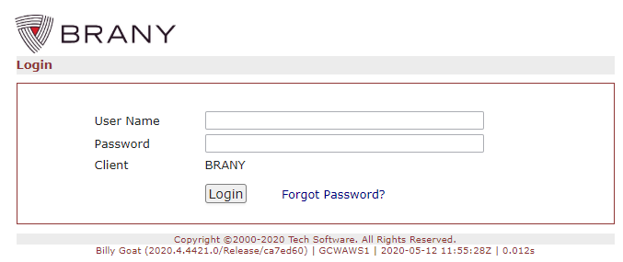

Q. I need to submit an amendment to my protocol. What should I do?
A. Once your protocol has been accepted in the BRANY IRBManager system, you will be able to submit requests directly to BRANY for review in their IRBManager system.
1. Log into IRBManager (https://brany.my.irbmanager.com )
2. Find the Study Details page by entering the BRANY # in the Find Study box on the upper
right or by selecting it from the active studies list at the bottom of your home screen
3. Once on the Study Details page, click Start xForm under the BRANY logo.
4. Select and complete the appropriate Modification Request xForm:
  - For biomedical research studies: 01-Modification/Request for IRB Review
  - For SBER studies: SBER Modification/Request for IRB Review

IMPORTANT NOTE: Clicking SUBMIT when the form is in the data entry stage means the form has been submitted to the PI for review and sign-off. The PI will receive an email alert with a direct link to the form so that s/he can login, view, and enter password to submit to the IRB for review.

Q. I need to revise my list of study personnel. What should I do?
A. You will no longer submit personnel changes to the NJH IRB. You will submit personnel changes to BRANY through their IRBManager system.

Submissions should be made as follows:

- xForm: 02-Study Staff Changes (not PI)
- For each key personnel to be added, attach evidence of completed training in human subject protections (per NJH’s requirements)

Note: Conflicts of interest should still be reported to NJH. BRANY will obtain COI management plans directly from NJH.

Q. I am actively working with research subjects (including recruiting, consenting, enrolling, collecting data). Do I need to alter my consent forms? Do I need to notify my participants of the change of IRB oversight?
A. The acknowledgement email you will receive from BRANY IRB will include both a consent form addendum and a ‘Letter to Subjects’ that can be used to notify research subjects of the change of IRB oversight. The acknowledgement email will include specific instructions about when this notification is required.

Q. How will I know that I need to submit a Continuing Review request?
A. BRANY IRBManager system will send email notices regarding the need for continuing review and the expiration date. Instructions for study closure will also be provided. The reminders are sent 45, 30, and 15 days prior to the expiration date. The automated reminders will cease when BRANY IRB receives and processes either an application for continuing review or a study closure notice.

Submissions should be made using one of the following forms:

Renewal
- For biomedical research studies: 11-Continuing Approval Application
- For SBER studies: SBER Continuing Approval Application

Annual Status Report (for non-expiring studies)
- 12-ANNUAL STATUS REPORT

Study Closure
- For biomedical research studies: 04-Study Status Change (Closed/Enrollment Closed)
- For SBER studies: SBER Study Status Change (Closed/Enrollment Closed)

Q. What events occurring in approved research studies require prompt reporting to BRANY IRB (and what are the Reporting Timelines)?

The following types of events require prompt reporting to BRANY IRB:

- Unanticipated problems involving risks to subjects or others: Events that meet all of the following three criteria:
  - (1) caused harm to one or more subjects or others or placed one or more subjects at increased risk, and
  - (2) was unexpected, and
  - (3) was related to the research procedures. Examples may include breach of confidentiality from inadvertent information disclosure or unintentional loss of records.
- Protocol deviations – an unintentional or accidental change to the IRB-approved protocol.
  - Major deviations are those that placed one or more subjects at increased risk, affected the rights and welfare subjects, or have the potential to recur without intervention. These must be reported within 10 days of occurrence (per the specified timeframe below).
  - Minor deviations are those that did not place one or more subjects at increased risk or did not affect the right and welfare of subjects. (Minor deviations are reported in aggregate to BRANY IRB at continuing review or with notification of study closure, using the Minor Deviation Log.)
- Changes to the protocol made without prior IRB review and approval to eliminate apparent immediate hazard to a research subject.
- Complaint of a subject that indicates unexpected risks or that cannot be resolved by the research team.
- Interim findings or reports that indicate any unexpected changes to the risks or potential benefits of the research, in terms of severity or frequency.
- Publication in the literature that indicates an unexpected change to the risks or potential benefits of the research.

Submit events requiring prompt reporting via the following form:

- 16-Reportable Event xForm

Event reporting must be in accordance with the timelines below:

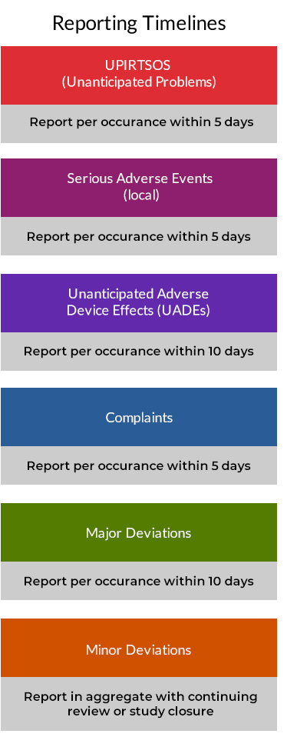

Q. Does BRANY offer any training on its version of IRBManager?

BRANY provides access to various training options to learn more about IRBManager on their website.

- Webinar – IRBManager Basics (46 minutes, with voice)
- Weblet – Where do I find Approval Documents (no voice)
- Weblet – How to submit a Continuing Review (no voice)
- Weblet – How to find my study in IRBManager (no voice)
- Weblet – How to start a XForm in IRBManager (no voice)

Once you have access to BRANY’s IRBManager, you will have quick access to the webinar/weblets (and PDF’s) from your Home page, under Useful Links in the left menu.

These can also be accessed on BRANY IRB’s website here:
https://www.brany.com/irb-manager/

Q. Whom can I contact with questions concerning BRANY submissions and IRB review?

Raffaella Hart Kerri Friel
Office: (516) 470-6909 Office: (516) 622-2040
e-mail: rhart@brany.com email: kfriel1@brany.com

A full list of BRANY IRB Contacts are available here.

Q. Whom can I contact with questions relating to NJH IRB submissions, or other institutional issues concerning human research?

Judy Matuk
Office: (631) 619-5990
Email: matukj@thehrpconsultinggroup.com

