**Adding Level of Service Speed Buttons**

1. When you are in a visit, on the **Visit Taskbar**, select the **Level of Service** button.

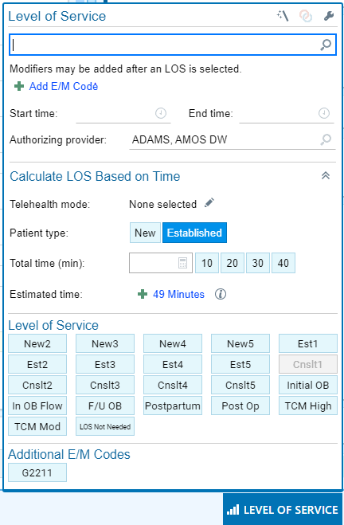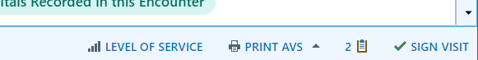

1. Select the **wrench icon** on the top right of the box to enter the personalization mode.
   * Please note, all changes made will reflect across all encounters.
2. Under the Level of Service or Additional E/M Codes, click on the **+Add** to enter the codes you use the most.
3. Enter the **caption and code**. To search for a code, you can select the magnifying glass for a list of codes. See List of Common Codes for a starting point.

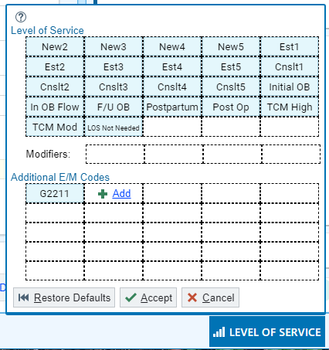

1. Click **Accept**.

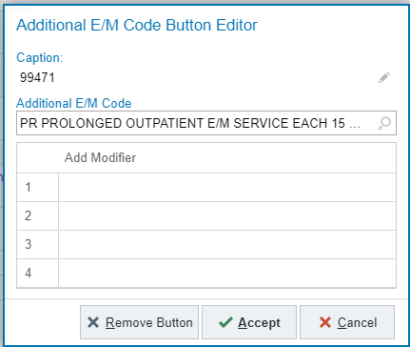



1. Once you have added all the **codes** you need, click **Accept**.

